K-PIPA Compliance for Log360
Strengthen data protection and meet K-PIPA compliance with Log360.
Region: South Korea | Type: Data Privacy | Category: Compliance | Pricing: Free

Overview
The K-PIPA compliance extension in Log360 helps organizations meet the Personal Information Protection Act (K-PIPA, South Korea), enforced by the Personal Information Protection Commission for entities processing Korean residents' personal data by providing centralized log management, intrusion detection, and access monitoring. The platform supports K-PIPA requirements for access control, audit logging, intrusion detection, encryption monitoring, breach detection and response, privileged access management, third-party processing controls, and network security across cloud and on-premise environments.
For Technical Security Measures Implementation (Article 29), Log360 provides comprehensive visibility across AD, Windows, and cloud sources, delivering system event monitoring and access logs that evidence active security controls. To address Access Control & Minimum Privilege (Article 29), the platform monitors AD logon, Windows logon events, failed authentication, Unix logon records, and Entra ID user logon to audit access restrictions across all personal data platforms. The extension also supports Audit Logging for Personal Data Processing (Article 29) by providing capabilities that collects EventLog reports, Windows system events, user auditing records, and file change logs as evidence that data access is continuously logged.

Key Features
- Intrusion Detection & Continuous Monitoring (Article 29): Log360 correlates Windows threat detection, network device attack reports, antivirus alerts, and firewall threat data to provide the real-time intrusion detection capability mandated by PIPA.
- Encryption & Sensitive Identifier Protection (Article 24, 29): Log360 monitors registry changes, policy modifications, and file operations to detect encryption policy violations and unencrypted handling of protected data assets.
- Breach Detection & Incident Response (Article 34): Log360 provides real-time threat detection and consolidated attack visibility that enables early breach identification supporting PIPA notification timelines.
- Third-Party Processing & Outsourcing Controls (Article 26): Log360 monitors cloud vendor user activity, AWS IAM events, unauthorized cloud access, and cloud login records to detect unauthorized third-party handling of personal data.
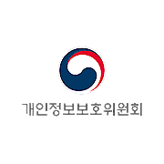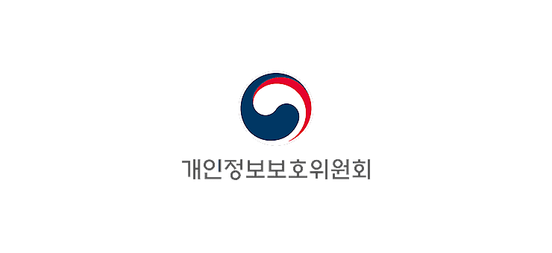

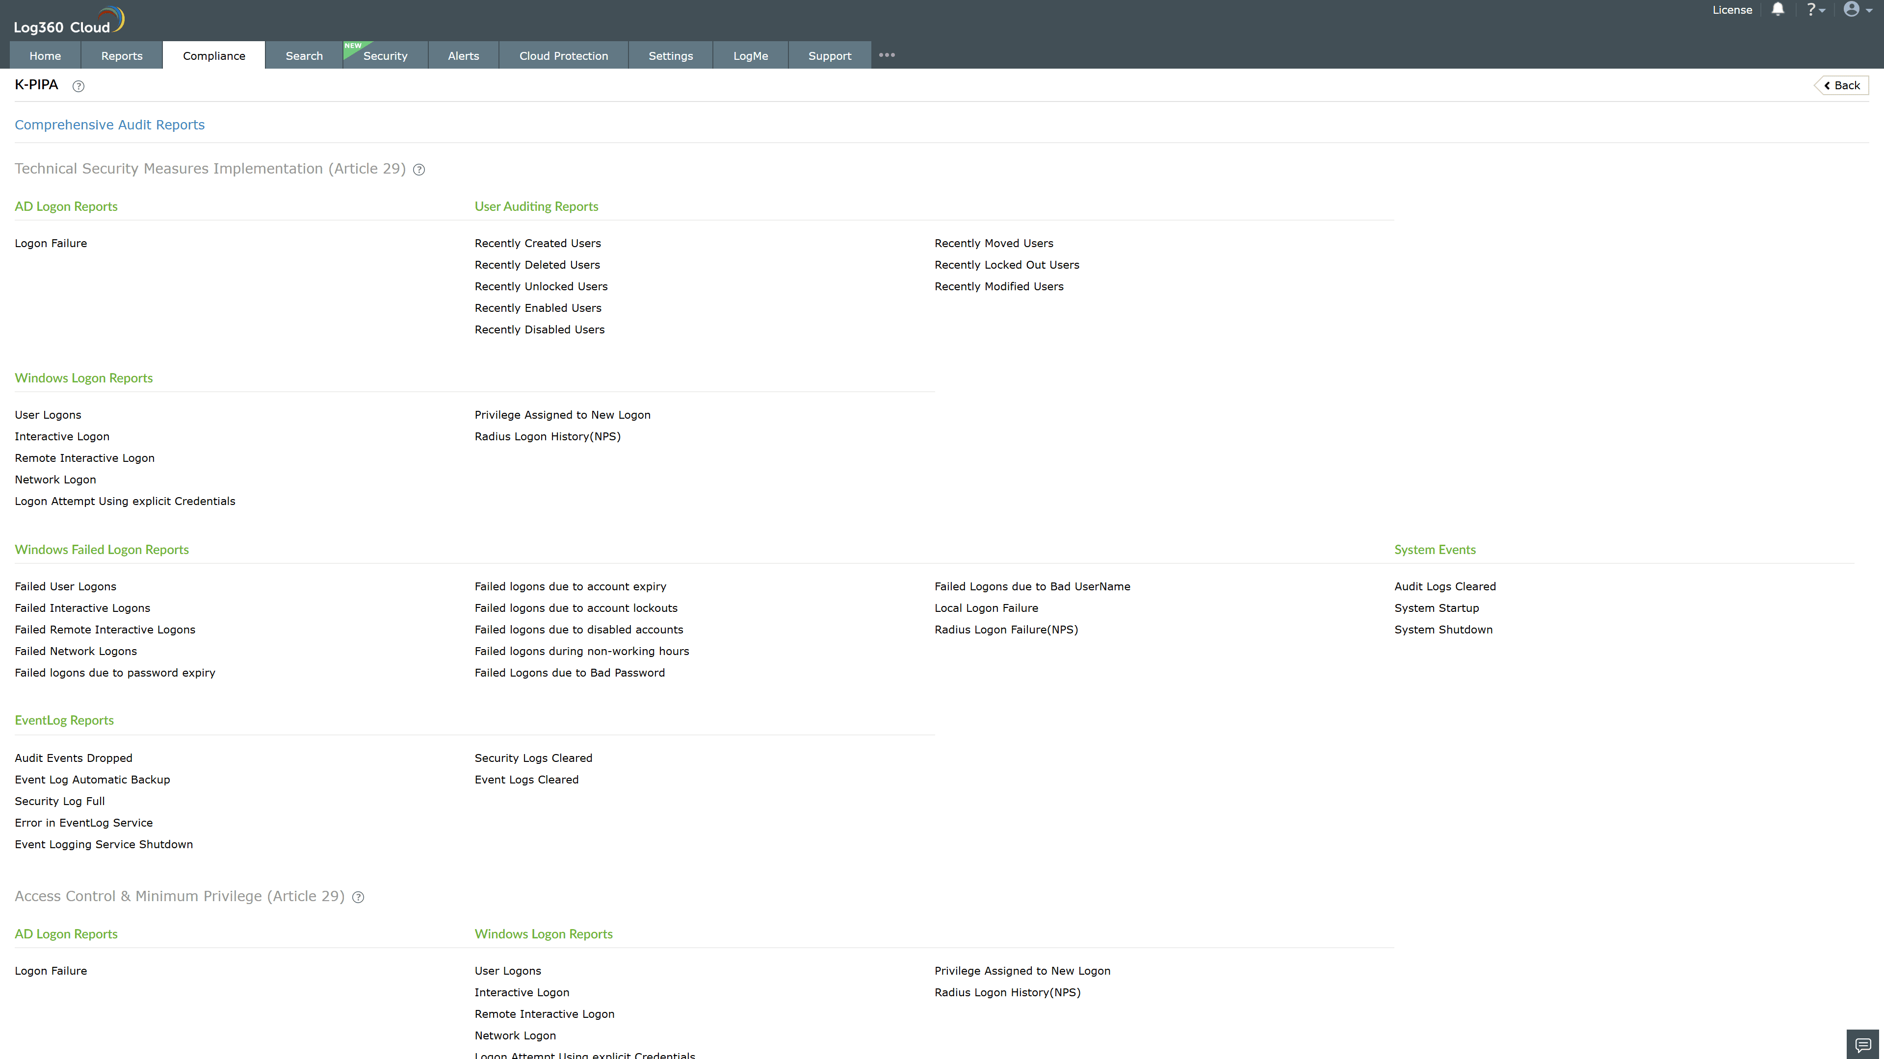
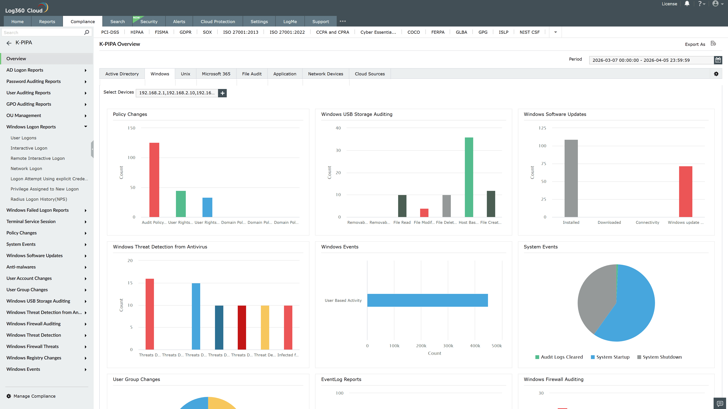
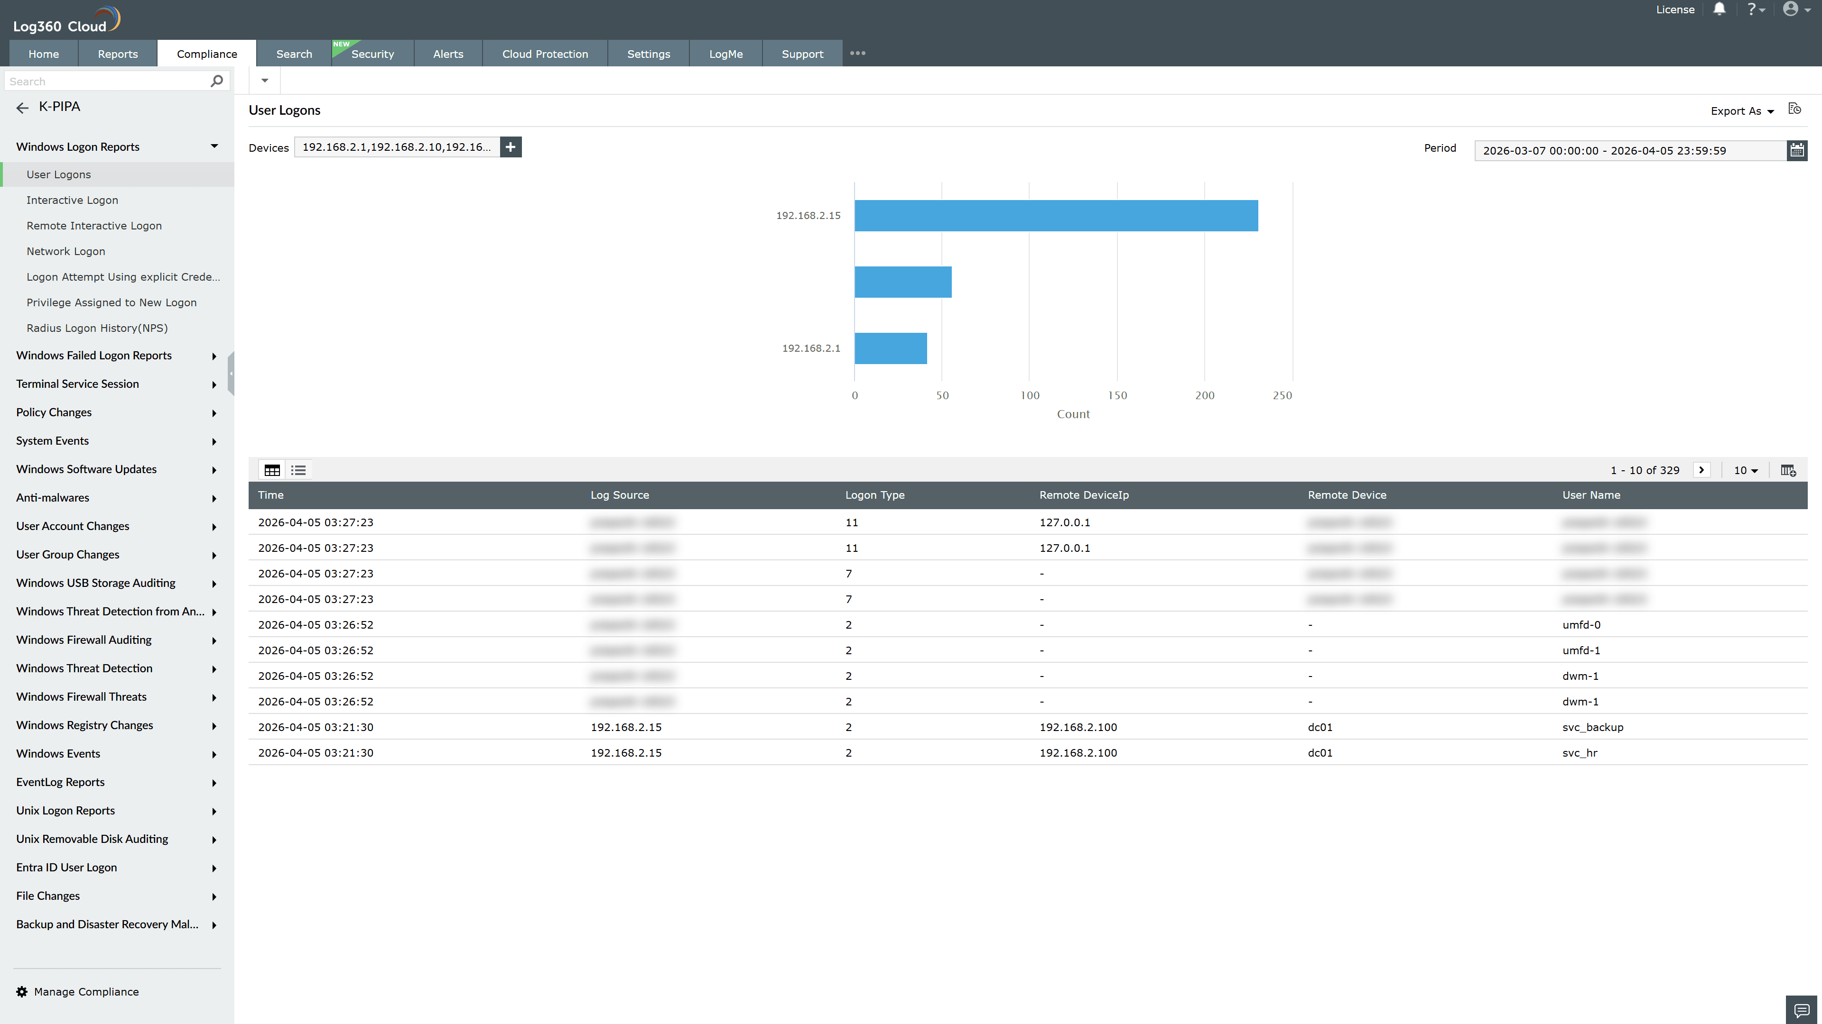
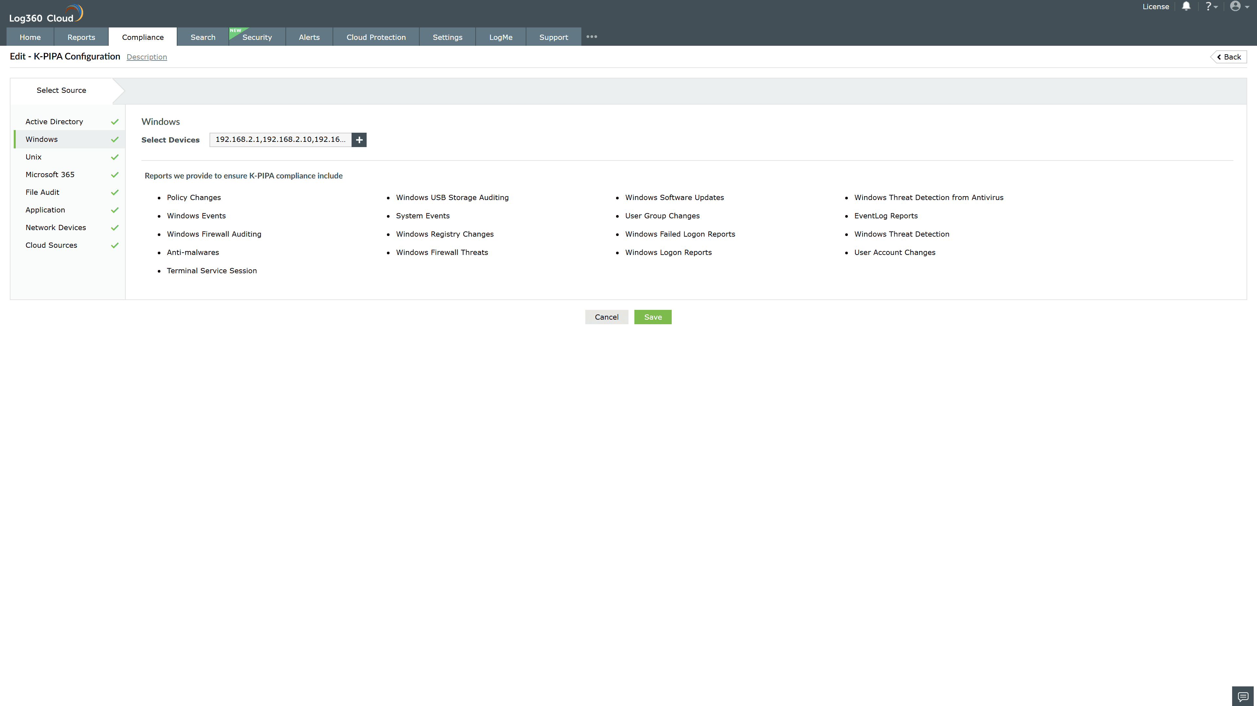
Valid Submission : Yes
Supported Editions : Free, Basic, Standard, Professional, MSSP
Help Document : https://www.manageengine.com/log-management/help/integrations/compliance-extensions.html
Help Video : Not provided
Tags : Log360, Compliance, Privacy monitoring, Data privacy, Regulatory compliance
Supported DCs : US, IN, JP, CA, AU, UK and EU
Privacy Policy:
Terms of Service:
Release Notes:
Predefined reports for the K-PIPA.

